Project Report:
Phishing Email Detection System
A Machine Learning MVP Integrated with MITRE ATT&CK Framework

Submitted by:
Amit Mitzmacher, Tal Mitzmacher

Introduction and Objectives
In this project, we developed a Minimum Viable Product (MVP) system to detect phishing attacks using machine learning techniques. Traditional cybersecurity defenses rely heavily on signature-based filtering, such as static blacklists or cross-referencing known malicious URLs. However, these conventional frameworks easily fail when facing "semantic camouflage" - a tactic where attackers hide malicious intent inside polite, professional, and grammatically flawless corporate emails.
Our primary goal was to train a high-performance Random Forest Classifier combined with TF-IDF Vectorization to analyze text traffic in real time.
Beyond just the statistical predictions, the system architecture maps flagged threats directly to the industry-standard MITRE ATT&CK Framework. By automatically adding this metadata, we provide Security Operations Center (SOC) analysts with immediate, actionable context regarding the attacker's tactical intent, making incident response much faster and more effective.

Dataset and Data Distribution
For this project, we utilized a comprehensive dataset containing 82,486 email samples. While the dataset maintains a near-balanced distribution to ensure robust adversarial learning, the raw distribution consists of:
- Safe Corporate Emails (Class 0): 39,634 samples (~48.0%)
- Phishing Threats (Class 1): 42,852 samples (~52.0%)
Although there is a slight structural skew toward phishing samples in the underlying historical archive, the distribution remains highly functional for training without introducing severe majority-class bias. To establish a rigorous validation baseline, we performed an 80/20 train-test partition, resulting in the following split:
- Training Set: 65,988 samples (used exclusively to fit the model and tune the vectorizer).
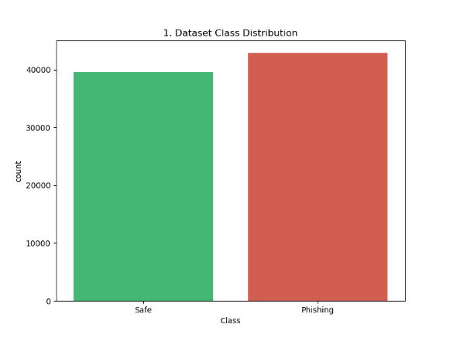
- Testing Set: 16,498 samples (held back entirely as an independent benchmark for final verification).

Performance Evaluation
To facilitate rapid experimentation and scale throughput, the Random Forest model was trained leveraging multi-core parallel processing computational resources (n_jobs=-1). Evaluating the trained model against the 16,498 completely unseen test samples yielded an outstanding overall macro accuracy of 99%.

Classification Metrics
A granular inspection of the precision, recall, and F1-score confirms that the decision boundaries established by the ensemble trees are highly robust across both classes:
Class Labels | Precision | Recall | F1-Score | Support (Test Samples)
Class 0  (Safe Traffic) | 0.99 | 0.99 | 0.99 | 7,935
Class 1  (Phishing Threats) | 0.99 | 0.99 | 0.99 | 8,563

Confusion Matrix Analysis
The absolute confusion matrix breakdown quantifies the precision of the model, demonstrating minimal margin of error across the 16,498 test vectors:
- True Negatives (TN): 7,827 legitimate corporate emails were correctly permitted.
- True Positives (TP): 8,452 phishing threats were successfully identified and blocked.
- False Positives (FP): 108 safe emails were wrongly flagged as phishing (False Alarms / Operational Friction).
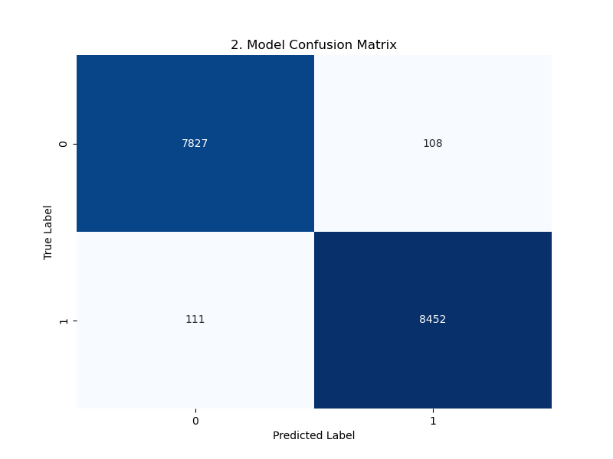
- False Negatives (FN): 111 sophisticated phishing threats slipped through the classification boundary.
ROC Curve and AUC Value
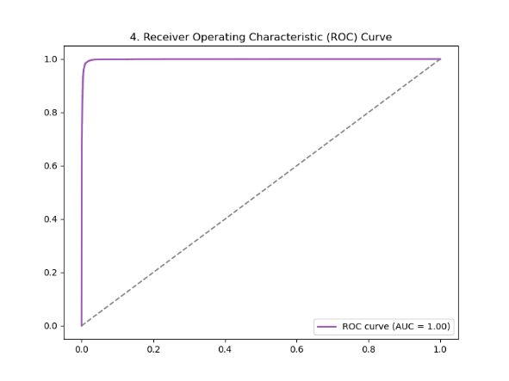
Plotting the Receiver Operating Characteristic (ROC) curve demonstrates an Area Under the Curve (AUC) value of 1.00 (rounded). This empirical result mathematically proves that the information density within our generated TF-IDF features provides excellent separability between benign enterprise communications and adversarial social engineering attempts.

Feature Importance Insights
We extracted the Gini importance values using the model's feature_importances_ attribute to analyze the top 10 most influential text tokens.
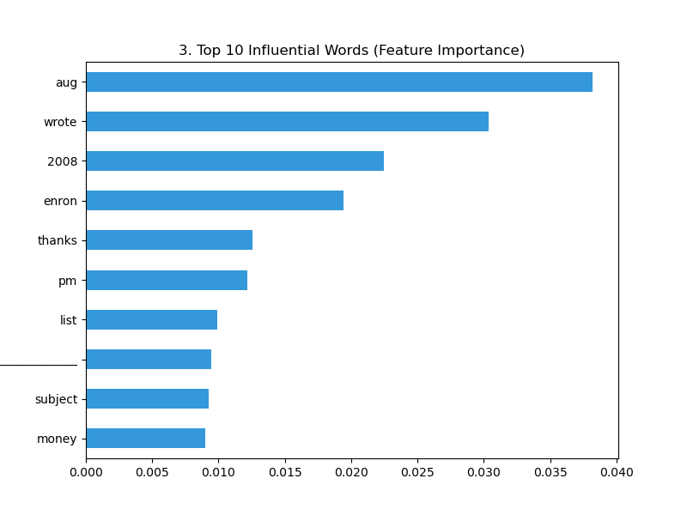
As shown in the chart below, historical archives introduced significant noise into our data through structural metadata and domain-specific terms from the Enron corpus (such as "aug", "wrote", "2008", "enron", and "thanks"), giving them a substantial amount of statistical weight. Crucially, the model anchors its predictive boundaries on these contextual and historical markers, alongside broad priority indicators like "money" and "subject".
Live Simulation and MITRE ATT&CK Mapping
To simulate real-world production deployment conditions, a continuous traffic stream was generated by dynamically injecting 100 random email variations. The live runtime execution produced an operationally realistic distribution: 20.0% safe corporate traffic and 80.0% phishing security alerts.
The system's real-time defensive posture was verified against two deterministic test cases defined in the project constraints:
Test Case B (Polite Attack Simulation): "Dear employee, please review the urgent project expense and verify your password."
Classification Result: PHISHING ALERT | Confidence Score: 55.00%
Analysis: Static string filters miss this vector due to ordinary tokens ("Dear employee"). The ML engine detected the latent threat, though the confidence index dropped to 55.00%. This lower confidence score accurately reflects the semantic dissonance between the polite preamble and the immediate behavioral request for sensitive credential verification.
Test Case A (Routine Workspace Email): "Meeting reminders: Please review the Q3 corporate reports."
Classification Result: SAFE | Confidence Score: 95.00%
Analysis: The system correctly confirms semantic legitimacy, ensuring day-to-day business productivity continues completely unhindered.

Every flagged anomaly undergoes immediate context enrichment by mapping the text signature directly to the MITRE ATT&CK Taxonomy matrix:
- Tactics: Initial Access (TA0001) / Credential Access (TA0006)
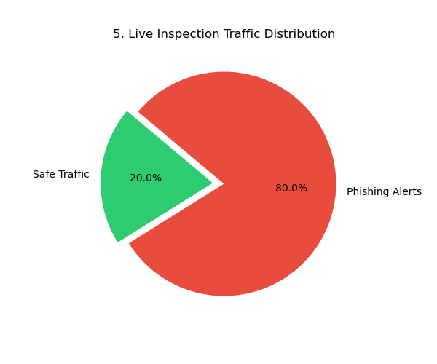
- Technique: Phishing: Spearphishing Link (T1566.002) / Adversarial Reconnaissance (T1598.003)

All inspection telemetry, confidence matrices, and tactical classifications were recorded via standard formatting pipelines directly into a production-grade audit ledger (traffic_logs.log) to support downstream SIEM/SOC software orchestration.

Conclusion and Future Directions
The engineered AI Cyber Shield MVP successfully achieved a macro accuracy rate of 99% and an ideal AUC metric of 1.00. Combining token-level statistical classification with real-time logging architectures and systematic MITRE ATT&CK mappings yields an intelligent, defense-in-depth security layer capable of defeating "semantic camouflage". Future development tracks will prioritize modernizing the vectorization block by transitioning from bag of words architectures to deep contextual embeddings and testing the system's resilience boundaries against polymorphic phishing campaigns systematically generated by advanced Large Language Models (LLMs).

